Laboratory 5 – Week 5
Loops

Introduction

Firstly, this worksheet is one of the worksheets from which your laboratory portfolio will be assessed [CodeRunner exam].

This laboratory worksheet covers loops in Java. We will be implementing some of the examples given during the lecture, followed by some additional examples.

Preliminaries

Create a new project and Java class called CS1702_Lab5.

What are Loops?

In mathematics, loops and repetitions refer to repeated applications of a particular operation or function. This repetition is often represented by summation, product notation, or recursive formulas.

For instance, the Summation symbol ($Σ$ sigma) can be used for working with a sequence of terms. Let’s say we want to work with the integers from 1 to $n$, we could write:

$$\sum_{i = 1}^{n}{f(i)}$$ | (1)

This expression with the $Σ$ symbol indicates that we apply a function $f(i)$ for every integer from $1...n$ which will implicitly sum the results. Therefore, since we are not applying any specific function, $f(i)$ just becomes $i$:

$$\sum_{i = 1}^{n}{i}$$ | (2)

This allows us to inherit the summative function of the sigma notation and if $n=3$:

$$\sum_{i = 1}^{3}{i= 1+2+3}=6$$ | (3)

Conditions and Loops

During the Week 4 lecture on conditional statements, we introduced piecewise functions. Consider the following expression $f\left(n\right)$ where $n=10$:

$$f\left(n\right)=\left\{\begin{aligned} +, &if n is even \\ (no symbol), &if n is odd\end{aligned}\right.$$ | (4)

This expression tells us to print a + symbol [System.out.print(“+”)] $if n is even$, and nothing (i.e. no symbol) $if n is odd$.

Combining this with a loop, we can print all odd/even numbers from $1...n(10)$:

$$\sum_{i = 1}^{10}{f(i)}$$ | (5)
And when evaluating this expression, we get:
$$\sum_{i = 1}^{10}{\left\{\begin{aligned} +, &if i is even \\ , &if i is odd\end{aligned}\right.}$$ | (6)

Note that, since we have defined an explicit function $f\left(n\right)$ with an expression, the $Σ$ symbol no longer summates (i.e. sums) the values of $n$ in programming context

To check for odd or even numbers, we can use the Modulo (mod) function which programmatically is represented as the % percentage symbol. Therefore, for each number that the loop iterates over we divide by 2, and thus apply the expression $f\left(n\right)$:

- $if(1 mod 2)==0$
- $if\left(2 mod 2\right)==0\left(+\right)$
- $if\left(3 mod 2\right)==0$
- $if\left(4 mod 2\right)==0\left(+\right)$
- $if\left(5 mod 2\right)==0$
- $if\left(6 mod 2\right)==0\left(+\right)$
- $if\left(7 mod 2\right)==0$
- $if\left(8 mod 2\right)==0\left(+\right)$
- $if\left(9 mod 2\right)==0$
- $if(10 mod 2) ==0(+)$

As a result of $f\left(n\right)$, we get 5 symbols “+++++” printed in the console. We can now try and write a Java for loop to represent this logic.
------------------- SEMINAR ACTIVITY -------------------

Java Loop Syntax

The syntax for loops in most programming languages operate in a similar way but are probably written in a slightly different manner. In Java a for loop is defined as follows:

for (<start>; <end>; <increment>)
{
//code
}

Each part of the loop has a set of requirements/questions that it checks (condition):

- <start>
  - Where should the loop start? (e.g., $(i=0)$ or $(i=1)$)
  - Is this a valid number (integer, float, double)?
- <end>
  - Where should the loop end?
  - Usually a condition, e.g. $(i<10)$, stop loop when $i$is one less than 10
  - Must be a valid expression that evaluates to true/false
  - Expression must relate to <start> to ensure it eventually ends
  - Can also decrease (go down, e.g., $(i=10) until (i>0)$
- <increment>
  - How much should the loop increase by (step size)?
  - For example, $(i)$ should go up by +2 or +3 every time or even -1

Create a new class called Exercise1 in the CS1702_Lab5 and copy/paste the following for loop example.

for (int i = 1; i <= n; i++)
{
System.out.println(i);
}

For the remainder of Equation (6) defined above, complete the logic by filling in $n=10$ and the conditional statement.

for (int i = 1; i <= <n>; i++)
{
if(<?>)
{
System.out.println(i + " (+)");
}
}

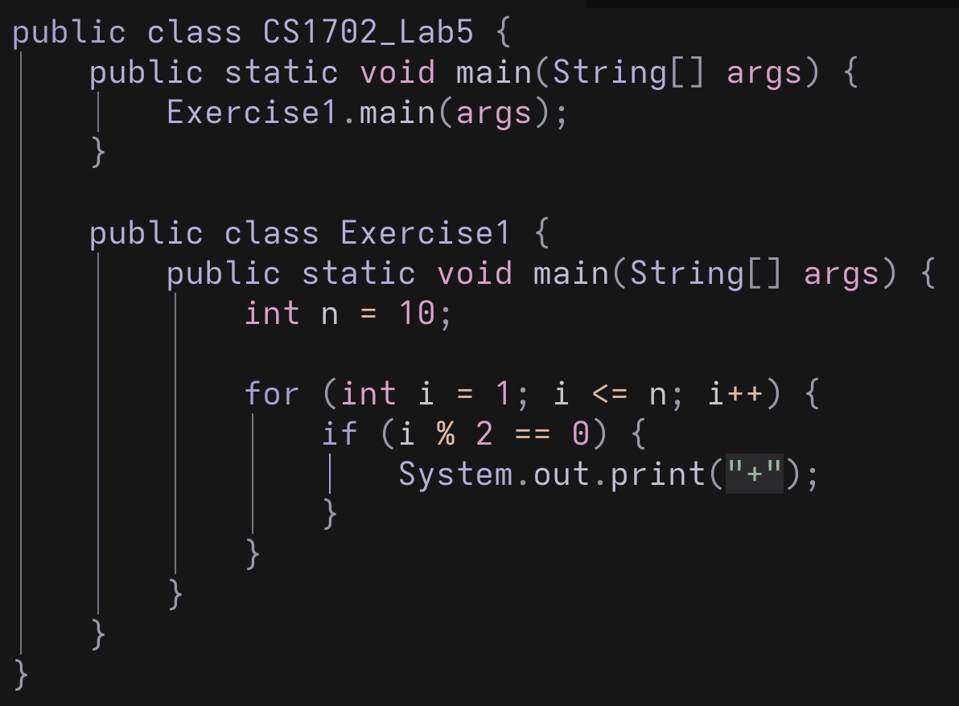

1: Odd/Even

Java While Loop Syntax

While loops are programmatically very similar to a loop, however they do not have direct mathematical notation. They are designed for indefinite repetition based on a condition rather than a fixed predicate or predictable endpoint.

while (<condition>)
{
//function
}

The condition has a few requirements that need to be met;

- <condition>
  - Can be any expression that evaluates to true or false
  - The loop needs to break – otherwise it will go forever!!

Create a new class called Exercise2 in the CS1702_Lab5 and copy/paste the following while loop example.

int x = 4;
int y = 5;

while (x < y)
{
// What happens?
System.out.println("Hi there...");
}

Nested Loops

Nested loops allow us to perform repeated actions within repeated actions. This is often used to process multi-dimensional data structures like matrices or to perform tasks that require multiple passes through a set of data.

suppose we have two loops that run from $1...m$ and $1...n$ respectively, performing some function $f(i,j)$.

$$\sum_{i = 1}^{m}{\sum_{j=1}^{n}{f(i,j)}}$$ | (7)

Create a new class called Exercise3 in the CS1702_Lab5 and implement Equation (7) where $m=5$ and $n=5$.

for(int i= <FILL>; <FILL> ;++i)
{
System.out.println(i);

for(int j= <FILL>; <FILL> ;++j)
{
System.out.println(" ----> " + j);
}
}

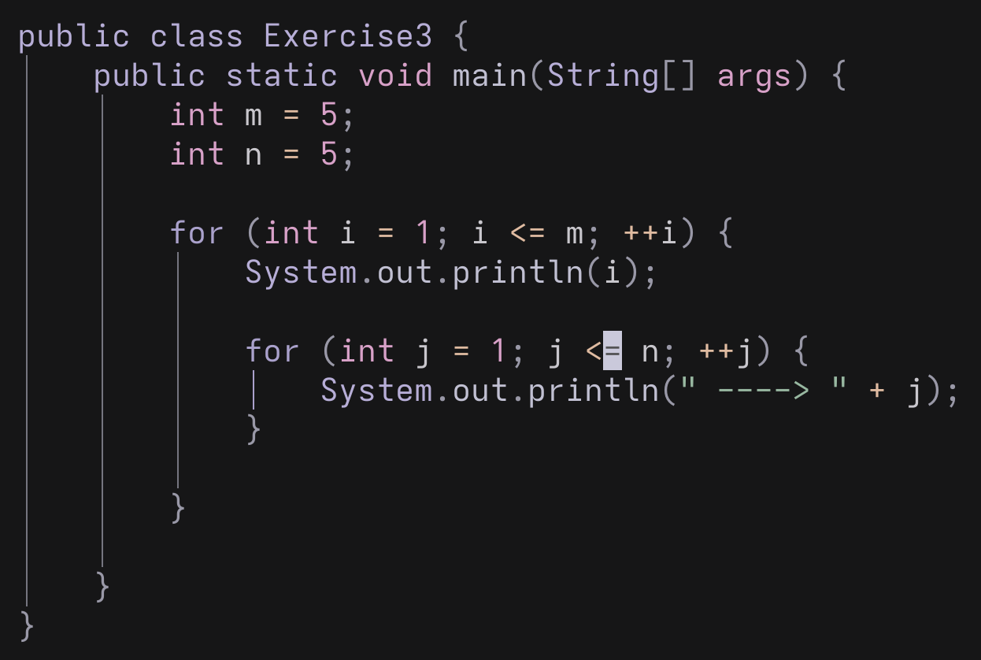

------------------ END SEMINAR ACTIVITY -------------------

Exercises

This lab’s exercises are made up of several sections related to the Week 4’s Lecture.

Generating Patterns Using For Loops

Based on Equation (6), and the Java code you created for the Odd/Even problem, modify the loop to produce the following sequences

- "++++++++++"
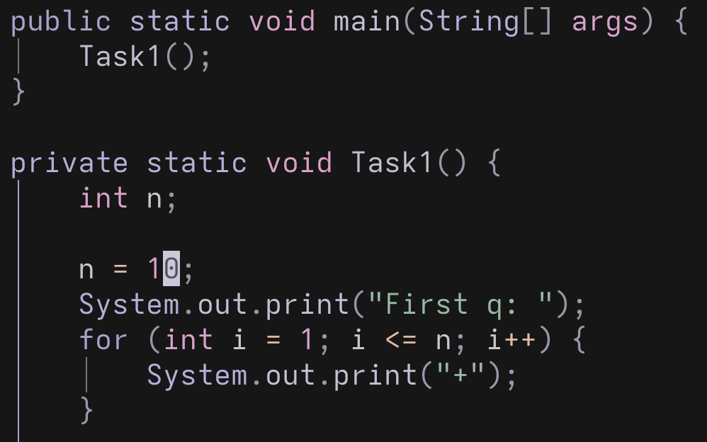

- "---------"
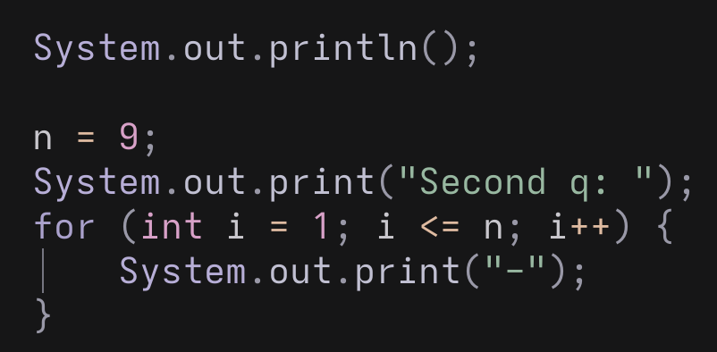

- "+-+-+-+-+-"
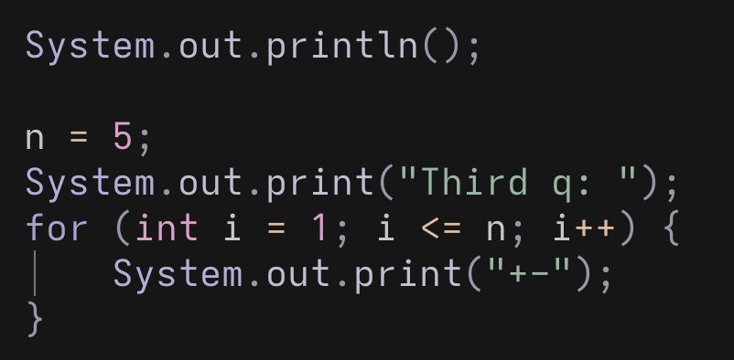

- "*+-*+-*+-"
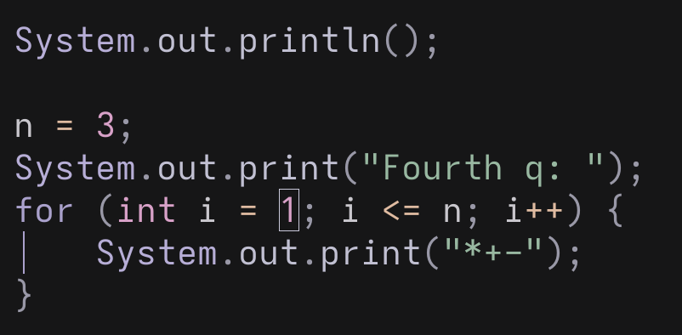

- "*+-*+-*+-*"
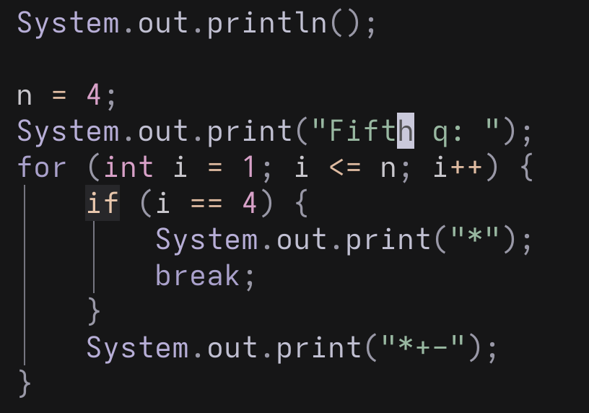

- "**++**++**++"
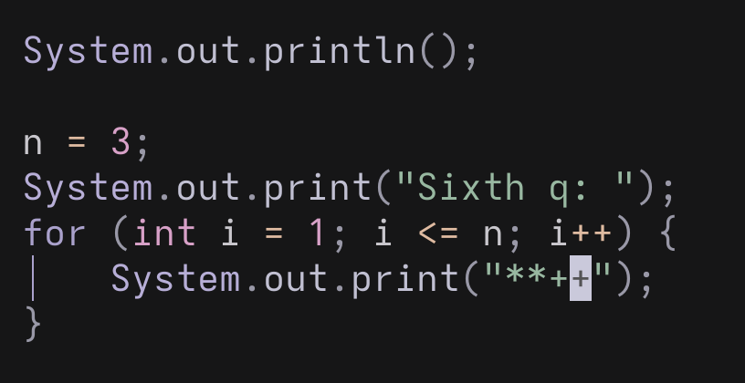

- "***+++---***+++---"
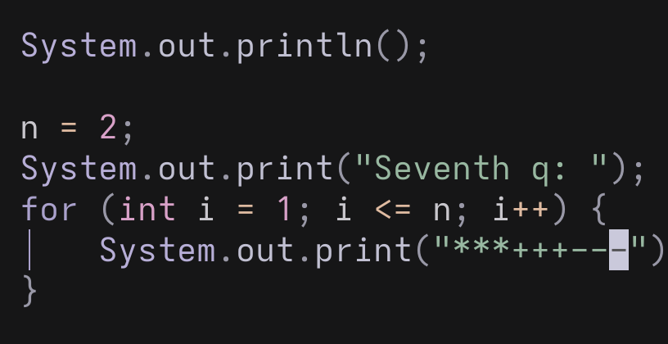

- "***+++------+++***"
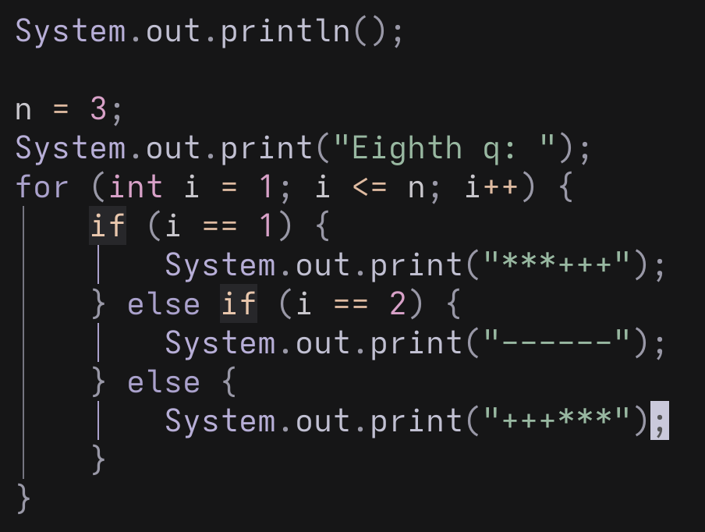

Generating Sequences Using For Loops

Based on Equation (6), instead of printing symbols, print the number patterns directly for the following sequences

- 4,5,6,7,8,9,10,11
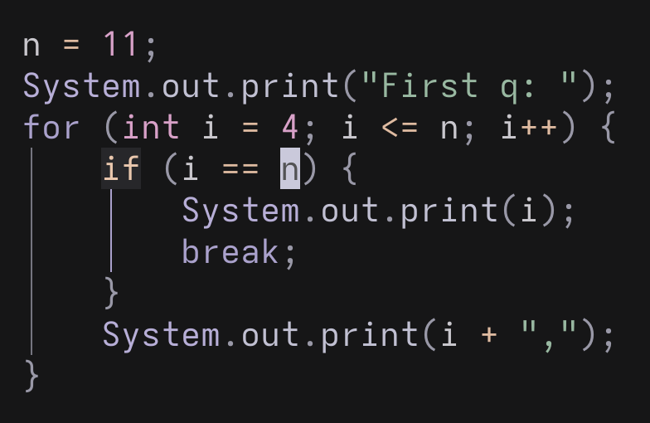

- 10, 13, 16, 19
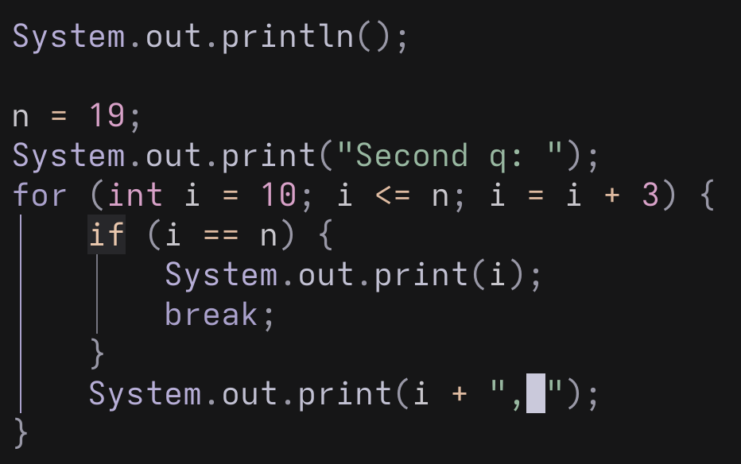

- 1, 4, 7, 10, 13, 16

- 2, 4, 6, 8, 10, 12

- 1, 4, 9, 16, 25, 36, 49, 64, 81, 100

- -10, -8, -6, -4, -2, 0, 2, 4, 6, 8, 10
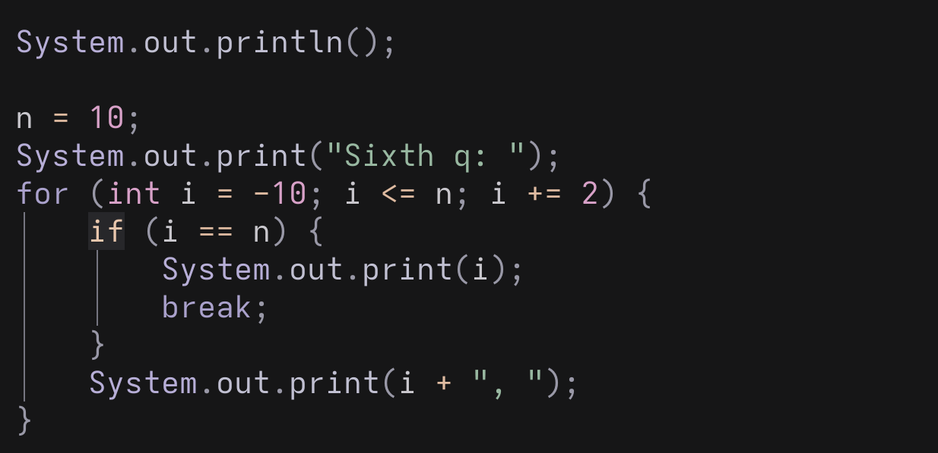

- -20, -15, -10, -5, 5, 10, 15, 20
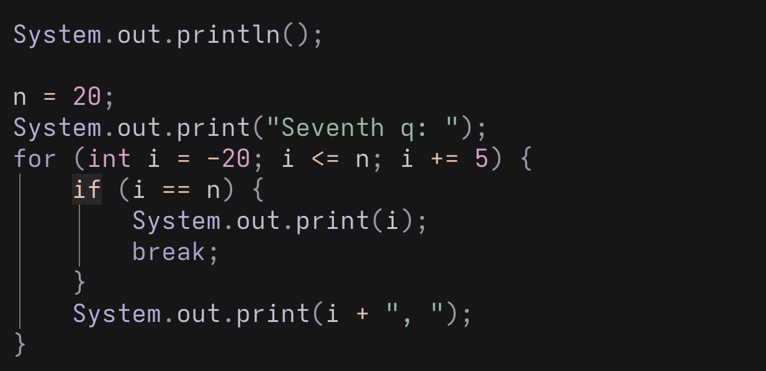

Implement Euclid’s algorithm

As a while loop exercise, take Euclid's algorithm. It finds the Greatest Common Divisor (GCD) of two numbers. The GCD is the largest number that will evenly divide both values (and leave no remainders). For example, the GCD of 270 and 192 is 6 because 270/6 and 192/6 has no remainders.

Using the piecewise function, we can represent GCD as:

$$gcd\left(a,b\right)=\left\{\begin{aligned} a, &if b=0 \\ gcd(b, a mod b), &if b≢0\end{aligned}\right.$$ | (8)
https://en.wikipedia.org/wiki/Euclidean_algorithm#Implementations
In this instance it is important to note that piecewise expression shows how the GCD can be computed but does not detail the mechanics of the algorithm.

Since the condition $if b≢0$ results in evaluating itself $gcd(b, a mod b)$, we can use a recursive function. However, we will save recursion for another lab sheet…

The other way is to evaluate using an indefinite repetition whilst a condition is true

Therefore, implement Euclid's algorithm (GCD) by using a while loop.

int a = 270;
int b = 192;

while (<fill in>)
{
// <Fill in>
}

System.out.println(a);

Test your program on the following:

- GCD(88,26)=2
- GCD(54,87)=3
- GCD(16,84)=4
- GCD(55,25)=5
- GCD(42,72)=6
- GCD(77,28)=7
- GCD(80,88)=8

Verify that GCD(a,b) = GCD(b,a).

This may seem daunting at first; however, it is straightforward if you consider the flow charts in the lecture notes. Look at the flow chart for Euclid's algorithm on page 18 of the week 4 lecture notes and the Wiki implementation pages, you should be able to construct a solution to this problem.

Nested Loops

Modify the loops to produce the following sequences:

- "122333444455555"
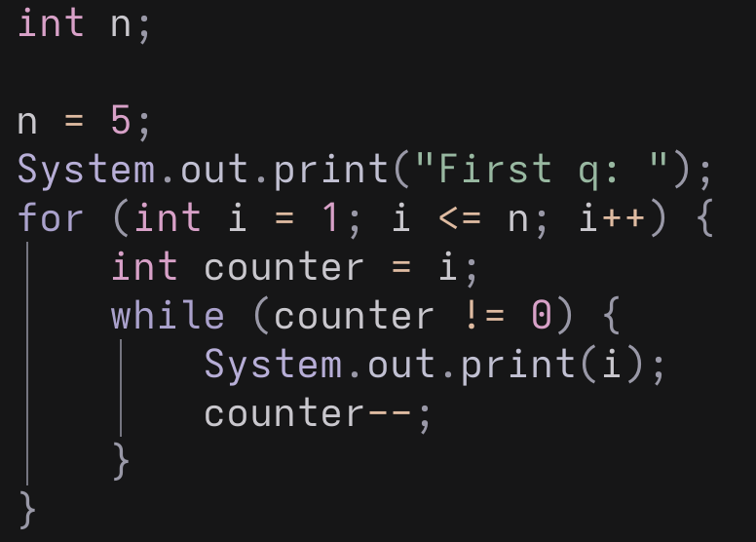

- "22333444455555666666"
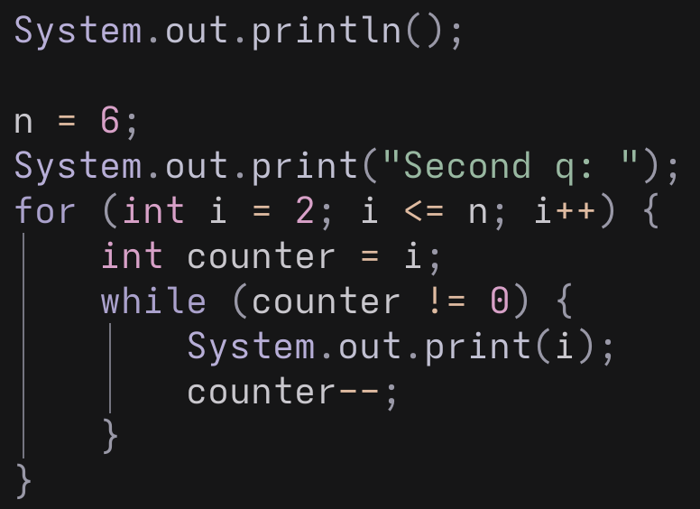

- "133355555"
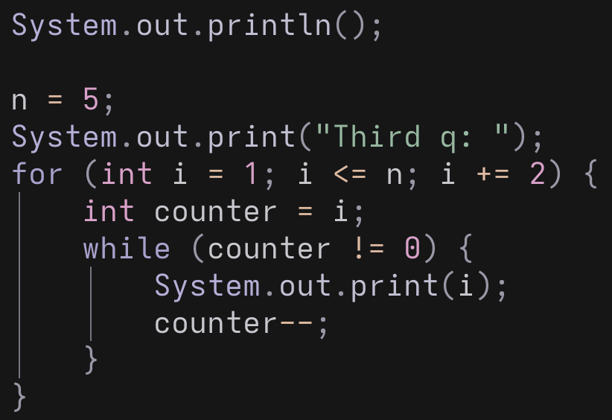
- "1335557777"
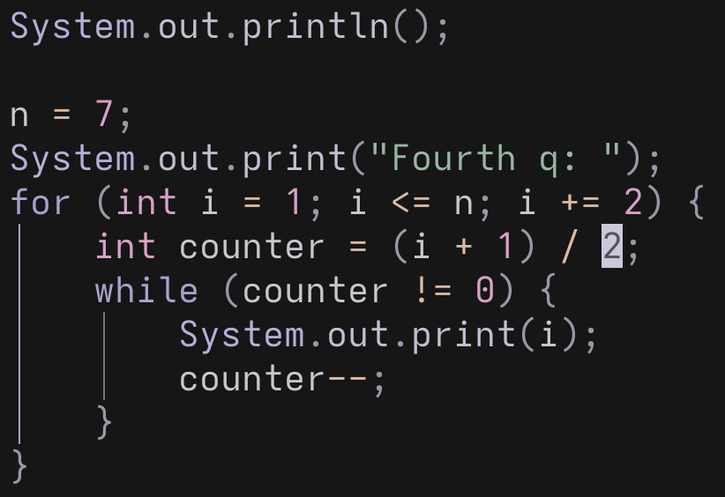

- "555554444333221"
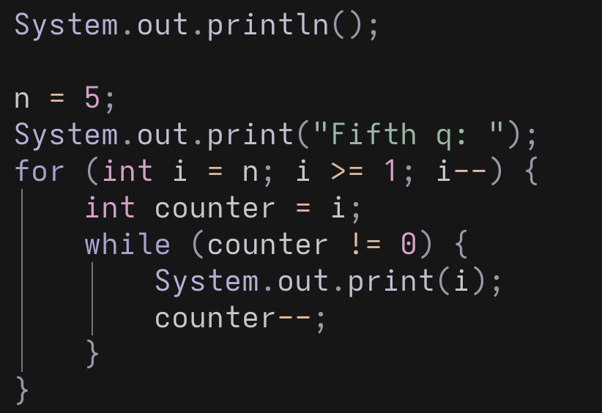

- "544333222211111"

- "+**+++****+++++"
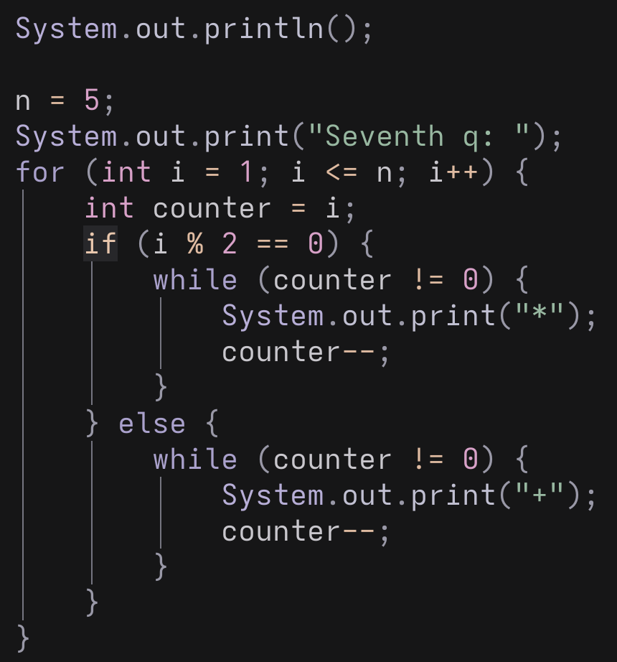

- "--***++++-----******+++++++"
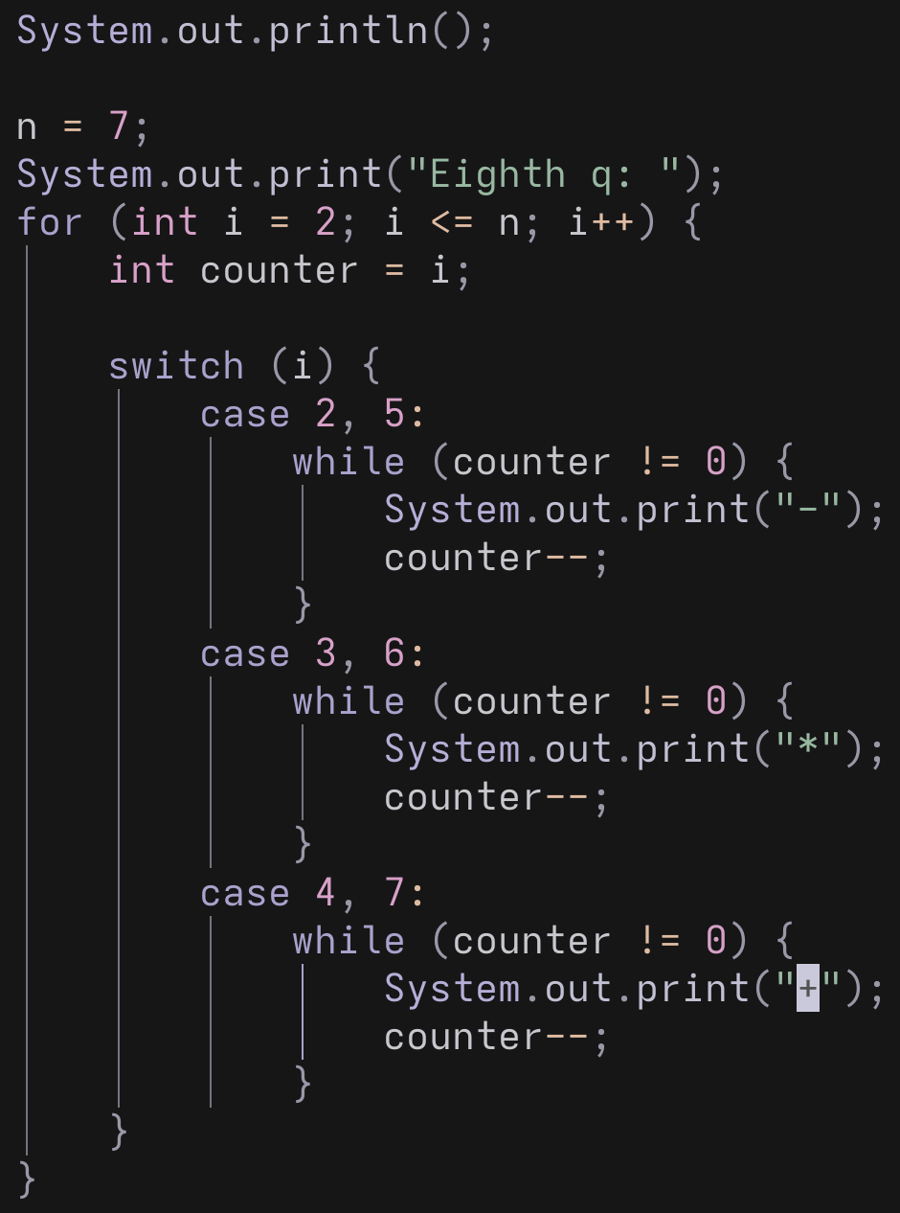

Write nested loops that perform the following tasks:

- Display all of the possible pairs of numbers between 1 and 10
  - (Hint: there are 100 pairs)
  - (Hint: Each pair consists of one number from the outer loop and one from the inner loop)

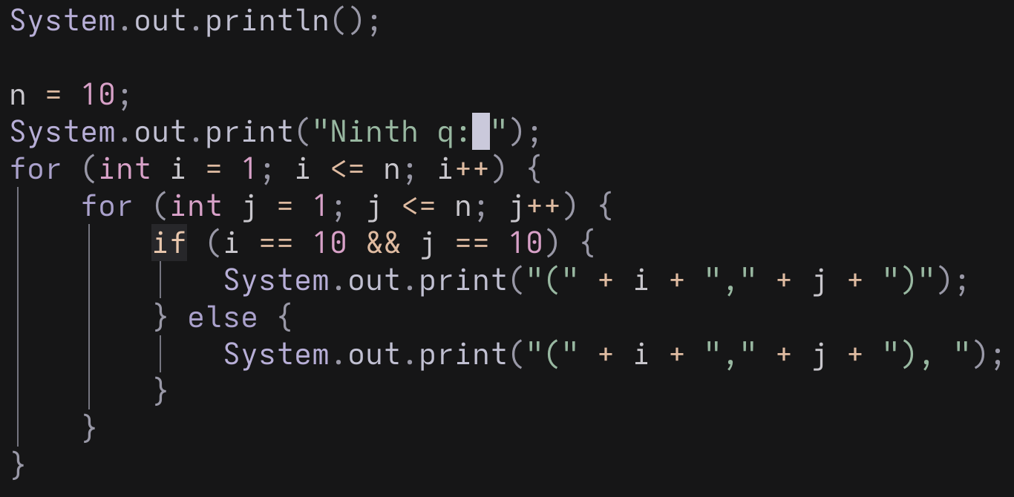

- Display all possible pairs in the form x, y where x < y and 0 < x, y < 11
  - (Hint: there are 45 pairs)

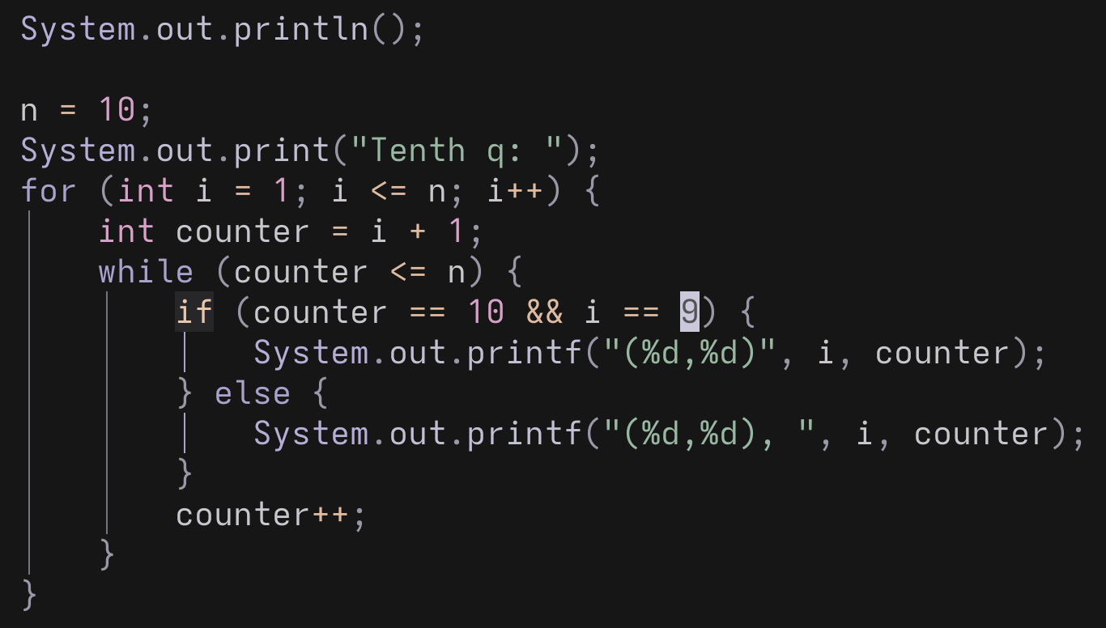

- Display all possible pairs of the numbers 1,2,3,4 paired with 4,5,6,7,8
  - (Hint: there are 20 pairs)

